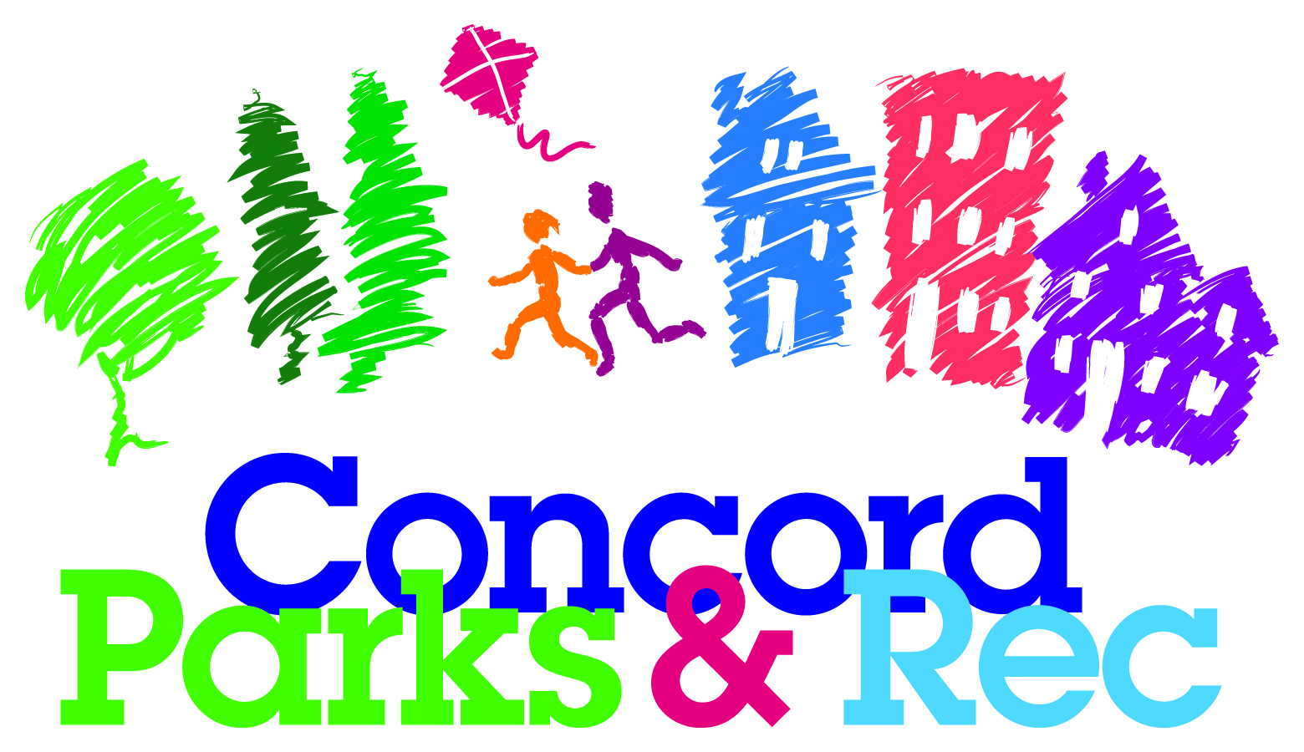
We Are Serious About Fun!
www.concordparksandrec.com
603-225-8690

PRESS RELEASE

December 2, 2019

The City of Concord and the Friends of White Park are happy to announce that Playgrounds by Leathers has been chosen to work with the community to design a new playground for White Park. Playgrounds by Leathers is a national playground company that specializes in community build playgrounds.

“We are excited to have Playground by Leathers involved in the new playground, as 27 years ago Leathers designed and assisted the community in the building of the current playground,” said Jonathan Smith, President of the Friends of White Park.
“The Parks and Recreation Department and the Friends of White Park will, once again, take a community approach to the design of the new playground,” said David Gill, Parks and Recreation Director for the City. David indicated that on Thursday, December 12th, Playgrounds by Leathers will be conducting design sessions with students and adults to gather their visions of a dream playground. During the day on December 12th, Playgrounds by Leathers will work with local elementary school students and, in the evening, there will be a community design meeting.

Although the final design and cost of the playground is still in the works, the Friends of White Park have indicated to the City that they will help raise 50% of the cost of the project. The Friends of White Park will be forming a steering committee and a fundraising committee over the next several weeks. If you are interested in serving on one of the committees, please send an email to Jonathan Smith at friendsofwhitepark@gmail.com

For more information on the City of Concord Parks and Recreation Department and/or the upcoming community design meeting, please visit www.concordparksandrec.com.

